**App**

**1. Define Users**

**2. Functionality for the App**

**Core Educational Features:**

* **Teaching Materials**: Videos, daily lessons, downloadable resources (e.g. pdf)
* **Learning Modules**: Structured by topics (e.g. diagnostics, device usage)
* **Training Modules / Device Learning Mode**: Simulated exams, William’s apps, and serious game / AR-based device training to simulate hands-on practice with Arclight tool.
* **Quizzes & Reviews**: Embedded spaced repetition system for retention

**Additional Features:**

* **Onboarding Process**: Tailored first-time user experience
* **Language Options**: Multilingual accessibility
* **Progress Tracking**: Learning progress saved locally or synced
* **Spaced Repetition Reminders**: For long-term knowledge retention
* **\*ALAN**

**3. Technical Parts**

**Platform**

* Mobile-first; potential deployment as:
  + **Progressive Web App (PWA)** – for offline support
  + **Native APK** – where internet access is limited
* **Offline Capability**:
  + Caching teaching materials and progress
  + Local video playback

**Serious Games / AR:**

* Serious games for applied learning
* Embedded Unity WebGL or native Unity builds for simulations
* AR-enabled components for realistic diagnostic training

**Analytics and Testing Tools:**

* SUS (System Usability Scale)
* IMMS (Instructional Materials Motivation Survey)

**4. User Journey**

**Learning Pathway:**

1. **Installation**: Via app store, APK sideload, or PWA link / QR code
2. **Onboarding**: Guided walkthrough of app features
3. **Learning Module**: Choose topics and begin lessons (text + video)
4. **Interactive Training**: William’s Apps, Serious Games / AR simulations, device mimicry, hands-on tasks
5. **Quiz**: Immediate and spaced-repetition-based questions
6. **Review**: Weekly reminders, scenario-based recaps
7. **Long-Term Retention**: Final spaced review and performance tracking

**App Content Details**

**1. Onboarding**

**Features**

- Language Selection

- Device Compatibility Check

- User Type Selection (Student/Clinician etc.) > lots of user pools

- Intro Tutorial (Video or Guided Tour)

**Content Focus**

- Welcome & App Purpose

- Navigation Walkthrough

- Link to Arclight Project Intro Video

**2. Learning Modules**

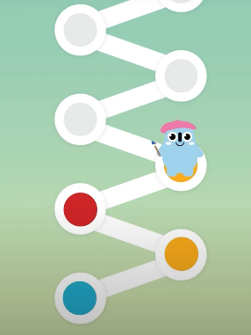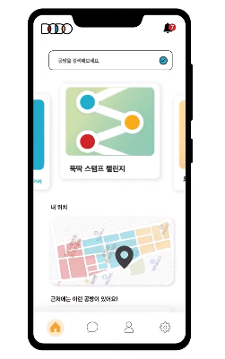

Learning tracking examples

**Features**

- Interactive Lessons

- Daily Learning Cards

- Videos

- Tracks Learning

**Content Focus**

- Eyes Modules (and Ear&Skin)

**3. Diagnostic Training**

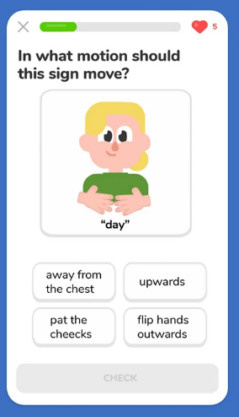

'What to ask patients' example

**Features**

- Case Study (Including ‘what to ask patients’, Swollen Disc, etc.)

- 3D Device Handling (AR/Serious Games)

- Quizzes per Topic

**4. Case-Based Scenarios**

**Features**

- ‘Guess What I Am’ Game

- Real-life Case Simulations

- Weekly Quiz and Review

- Spaced Repetition

**5. Review & Assessment**

**Features**

- Test Yourself Section

- Progress Tracker

- Final Knowledge Check

**Content Focus**

- Comprehensive Review

- Retest of All Major Tools

- Workshop Delivery Mode

**6. Community & Links**

**Features**

- Mentorship Forum

- Resource Library

- Offline Help Guide

- My Account

**Content Focus**

- Links to Orbis, RCO, AAPOS, WHO

- CVI Scotland, SightSIM

- RAAB Tools and Community Health Info